Lalor Secondary College
118 David Street Lalor 3075
PO Box 1015 Lalor 3075
Telephone 9463 7300
Facsimile 9465 3865
Email: lalor.sc@edumail.vic.gov.au

LALOR SECONDARY COLLEGE

Learning, Assessment and Reporting Policy

2022

AIM

To achieve continuous improvement in students learning, by assisting teachers to develop effective teaching and reporting practices based on consistent and agreed guidelines.

Date ratified by School Council: 9th December 2021
Review date: October 2022

LEARNING

PURPOSE
Both the curricular and the extra-curricular programs offered at Lalor Secondary College are mindful of the unique stages of development experienced by individual students throughout their schooling. Learning should ideally involve the pursuit of new ideas, insights, attitudes, knowledge, understanding and skills, which should be aimed at fostering the development of deeper thinking skills and therefore deeper learning.
Lalor Secondary College will base its Teaching and Learning programs at Years 7 -10 on the Victorian Curriculum. The Victorian Curriculum sets out what every student should learn during their first eleven years of schooling. The curriculum is the common set of knowledge and skills required by students for life-long learning, social development and active and informed citizenship.
The Victorian Curriculum F–10 incorporates the Australian Curriculum and reflects Victorian priorities and standards. Lalor Secondary College will offer a wide range of subjects. All Curriculum offerings and Assessment requirements will reflect The Victorian Curriculum and VCE study outlines.

Each year submissions are allowed by LSC staff members during Term 2 for additional subjects to be added to the established curriculum structure. The submissions are assessed by the Teaching and Learning team and a recommendation made to the school Principal who has the final decision.
Every 4 years in line with the school review, a Curriculum Review will take place led by the Assistant Principal who oversees Teaching and Learning. The review will consider structure, subject offerings and use all available data to inform the review process. Staff are offered the opportunity to provide feedback on any recommendations made prior to the final report being presented to the Principal for consideration.

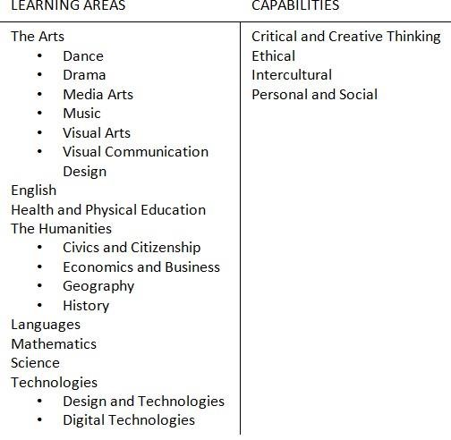

PRINCIPLES
At Lalor Secondary College learning should:
- Foster the pursuit of individual excellence and promote the development of life-long learning in all students
- Be a process where effective assessment and reporting practices ensure the accurate measure of individual student achievement and their relative progress.
- Be informed by individual student data, through the use of the Inquiry Cycle (Timperley Model)
- Be a process where effective assessment and reporting practices ensure the ongoing development of each student

- Incorporate the strategies from the LSC Instructional Model, including the High Impact Teaching Strategies (HITS) as well as HRLTP’S and Berry Street Education Model
- Promote success, independence, self-motivation, self-confidence and be provided in an environment that is inclusive, altruistic, supportive and productive
- Involve and encourage student agency in discussion about content, learning and assessment
- Recognise individual learning styles and achievements
- Take into account the diverse needs, interests and cultures of all students
- Value practice beyond the classroom and refer to contemporary global events and issues
- Present authentic tasks that require complex thought and allow time for exploration
- Be a process where effective assessment and reporting practices ensure the ongoing development of each student

ASSESSMENT

PURPOSE
The purpose of assessment at LSC is to support and improve student learning and performance.
Assessment at LSC allows teachers to evaluate the effectiveness of the learning and teaching processes as well as to diagnose individual, class and whole school learning needs. It presents an opportunity for both staff and students to identify strengths and weaknesses and to help teachers to follow the development of students and monitor areas of their learning that require improvement.
Assessment is also vital in acknowledging student achievement and evaluating student progress in relation to state-wide or national standards (e.g. Victorian Curriculum).

PRINCIPLES
Assessment at LSC should:
- Acknowledge student achievement in relation to the achievement standards (the Victorian Curriculum and Outcomes/Assessment Tasks (VCE, VCAL, VET)
- Present information in clear, concise language which will promote self-confidence and self-motivation
- Allow students the opportunity to demonstrate what they know, understand and can do in a variety of ways
- Provide planned and modified learning assessment tasks as required to cater for all students. Refer to Modified Assessment Policy.
- Support the development of the skills and knowledge to participate fully in the processes of assessment
- Come in the form of ‘assessment for learning’, ‘assessment as learning’ and ‘assessment of learning’
- Provide opportunities for students to complete assessments where students may be involved in alternate programs, are absent, or are suspended at the time in which the assessment originally occurred

Evidence of Assessment
Evidence of student demonstration of learning outcomes is obtained from a variety of sources and gathered and recorded over time using diverse assessment techniques and recording instruments. Evidence should be relevant to the learning outcomes that are being assessed and should be gathered and recorded in a focused and systematic way. Evidence must link to the Victorian Curriculum and VCE study designs. Teachers should select assessment techniques that best suit the context in which the learning outcome is being demonstrated and the type of evidence that is required. Students should be made familiar with the techniques through relevant modelling and practice. Common rubrics should be used where multiple classes of the same subject exist.
Judgements about student achievements are made on the basis of assessment evidence collected using the following processes:
• Achievements in the Common Assessment Tasks.
- Observation and anecdotal records of students in learning situations
- Annotated work samples
- Checklists
- Running records of student progress throughout the unit/course
- Conferencing with the students, peers, parents and teachers
- Portfolios
- Self-assessment and written reflections
- Peer assessment
- Records of assigned tasks.
It is an expectation that all teachers at Lalor Secondary College will modify student assessment where appropriate and in accordance with the Modified Assessment Policy.

REPORTING

PURPOSE
At Lalor Secondary College, ongoing communication between parents and teachers is essential in providing the best education for each student.
Reporting provides information on:
- Accurate student achievement and progress. Common Assessment Task achievements.
- Evidence gathered and teacher judgements made about student demonstration of learning outcomes

Students and parents should be provided with timely and accurate information that they can understand, interpret and use to support learning. Reporting should be provided using language, modes and formats that are both meaningful and relevant to the parents and students.

PRINCIPLES
Reporting should provide:
- Ongoing feedback about student progress in relation to learning outcomes
- Constructive and supportive feedback on how students can continue to make progress in relation to the learning outcomes

METHODS OF REPORTING
- Continuous Reporting- Results and feedback for all Common Assessment Tasks (CATs) throughout the semester, will be provided by teachers and be available to parents allowing for continuous updates on student progress
- Progress Reports - End of Term One and Term Three, through the Compass Reporting package
- End of Semester Reports, through the Compass Reporting package
- Parent/Teacher Interviews
- Ongoing communication throughout the year where necessary (refer to LSC Communication Policy)
 | Areas Of Assessment
Subject | Organisation | Effort | Classroom Behaviour | Completes Homework | Progress to Date | Interview | Subject Avg.
ART  Teacher Name | Satisfactory | Satisfactory | Satisfactory | Not Applicable | Satisfactory | Welcomed | 2.00
Science  Teacher Name | Good | Satisfactory | Needs  Improvement | Needs  Improvement | Satisfactory | Required | 1.80
Humanities  Teacher Name | Good | Good | Needs  Improvement | Good | Good | Welcomed | 2.60
English  Teacher Name | Satisfactory | Satisfactory | Satisfactory | Satisfactory | Satisfactory | Welcomed | 2.00
Health and  Physical  Education  Teacher Name | Excellent | Excellent | Good | Good | Good | Welcomed | 3.40
Languages -  Italian  Teacher Name | Not Assessed | Not Assessed | Not Assessed | Not Applicable | Not Assessed | Not Applicable | N/A
Mathematics  Teacher Name | Good | Good | Good | Good | Satisfactory | Welcomed | 2.80
7 Sport  Teacher Name | Excellent | Good | Good | Not Applicable | Good | Welcomed | 3.25
Food Technology  Teacher Name | Needs  Improvement | Needs  Improvement | Poor | Needs  Improvement | Needs  Improvement | Welcomed | 0.80
Performance Avg. | 2.75 | 2.50 | 1.88 | 2.17 | 2.25 | N/A | 2.32
- If there are matters of concern, teachers will contact parents and make an appointment for an interview as the need arises at other times. In special circumstances, an interview over the phone is a viable option if parents are unable to attend. Teachers are required to detail the communications on Compass in the student chronicle

ASSESSMENT FORMATS
PROGRESS REPORTS – Year 7 to 12.
The level of achievement for each criterion (shown in the table below) indicated by the following Excellent
Good
Satisfactory
Needs Improvement
N/A – This result should only be issued after consultation with the relevant Student Manager and Curriculum Leader.

END OF SEMESTER REPORTING – Year 7 to 10.
The end of semester report will be divided into 4 main areas. These 4 areas are Learning Focus, which includes Key Knowledge and Key Skills; Work Habits; Common Assessment Task Results and Feedback; and Areas for Further Improvement represented as dot point comments. The report will also include an overall Semester Result Subject Average based on the student’s performance in the assessment tasks for that subject. If appropriate, most subjects will include a percentage class attendance figure.

MODIFIED REPORTS
Students who fall under the eligibility status within the Modified Assessment Policy will receive teacher comments indicating any modifications to the assessment. Modified reports will include a heading to indicate that one or more of the assessments task have been modified for the student.

LEARNING FOCUS
KEY KNOWLEDGE:
This area outlines the Key Knowledge for each learning area specific to the subject being assessed.

KEY SKILLS
This area outlines the key skills required for each subject and is specific to the individual subject being assessed. Each skill required is a description of what should be achieved by the student participating in the subject in the semester.

WORK HABITS
This criteria is to assess the students’ overall effort in regard to a number of key work habits. These work habits are assessed across all faculty areas according to the scale shown below.

WORK HABIT | Needs Attention | Satisfactory | Good | Very Good | Excellent
Effort
Organisation
Classroom Behaviour
Completes Homework

COMMON ASSESSMENT TASKS AND FEEDBACK
The Common Assessment Tasks are graded as a percentage result as shown in the table below. A 50% average is required across all assessment tasks for a Satisfactory Completion to be awarded for the subject. An average of 49% or below will be deemed as a Non-satisfactory completion. This may have ramifications in regard to being promoted into the next year level. (Refer to the LSC Promotion Policy).
Task Feedback is provided at the completion of the learning task by the teacher and made visible to parents through Compass.

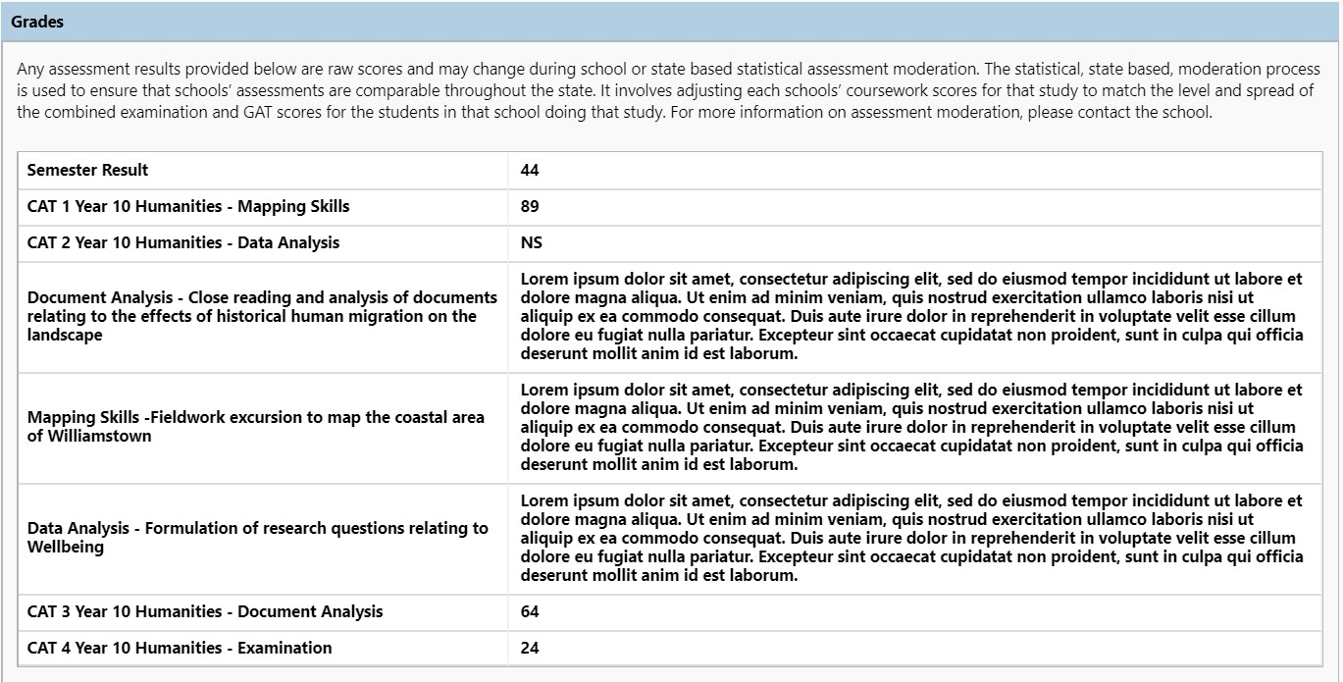

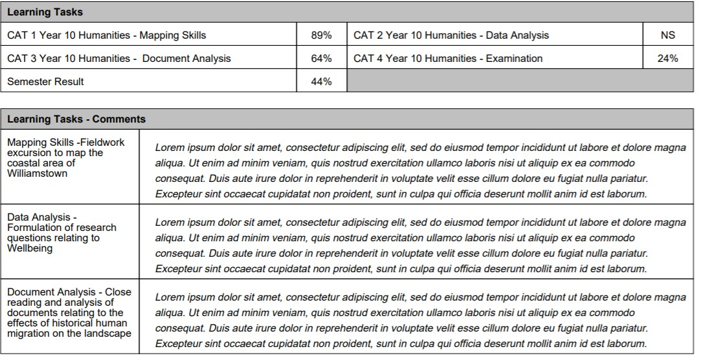

SEMESTER RESULTS
A semester result will be assigned to each Learning Area and will be calculated as an average of all common
Assessment Tasks. For year 7 sport, it will be calculated in accordance with a prescribed performance rubric.
Students participating in Boost, or the Instrumental Music Program will not receive a semester result in this format.

AREAS FOR IMPROVEMENT
In the Areas for Improvement, parents can expect teachers to make comments on areas that need improvement and the strategies that will work towards improving those areas.
As outlined in the Reporting Advice document issued each semester to staff, it is expected that report comments should be clear and provide detailed advice to parents regarding student performance and required improvements. This will be provided to parents at the end of semester, at the completion of Semester Reports.

AREAS FOR IMPROVEMENT
In order to improve further Jennifer needs to
- Ensure she includes detailed evidence to support all of her ideas within text response essay.
- All work should be proofread prior to submission to ensure errors can be corrected.

END OF SEMESTER REPORTING – VCE
The End of Semester reports for VCE students will be in the same format as the Year 7 to 10 reports
Achievement of each Outcome will be determined to be Satisfactory or Not-satisfactory based on the student’s performance in the Assessment Tasks listed below the Outcomes. There will not be an end of Semester Two report for Year 12 students.

LEARNING FOCUS
KEY KNOWLEDGE:
This area outlines the Key Knowledge as specified in the Study Design for each subject area specific to the subject being assessed.

WORK HABITS
This criteria is to assess the students overall effort in regard to a number of key work habits. These work habits are assessed across all faculty areas according to the scale shown below.

WORK HABIT | Needs  Attention | Satisfactory | Good | Very Good | Excellent
Effort
Organisation
Classroom Behaviour
Completes Homework

ASSESSMENT TASK RESULTS
UNIT ONE and TWO Results:

Unit One and Two assessment tasks results will be recorded as percentages. They will be related to the outcome. Each SAC/SAT will be awarded a result and will have a separate individualised comment.
LEARNING TASKS | Result % | Task Feedback
Task 1. Investigation | 80%
Task 2. Practical Activity | 78%
Task 3. Extended Investigation | 45%

UNIT THREE Results:
Unit Three results will be recorded as Graded Assessment raw scores according to the Assessment guidelines outlined in the subjects’ Study Designs. Each SAC/SAT will have a separate comment and mark.

OUTCOME | Result | Task Feedback
Outcome Number One, Unit 3  Task 1. Investigation  TASK MARKED OUT OF 30 | 25
Outcome Number Two, Unit 3  Practical Activity  TASK MARKED OUT OF 30  Unit 3 Extended Investigation  TASK MARKED OUT OF 40 | 28  35
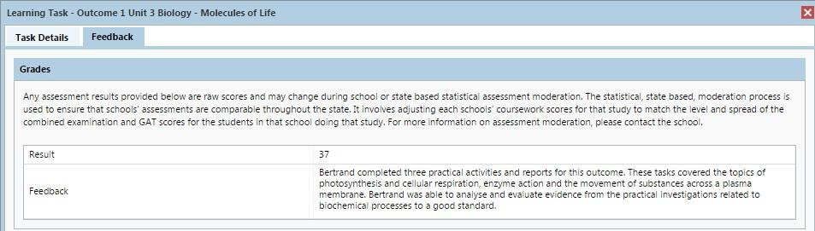

Areas for Improvement

In the Areas for Improvement parents can expect teachers to make comments on areas that need improvement and the strategies that will work towards improving those areas.
As outlined in the Reporting Advice document issued each semester to staff, it is expected that report comments should be clear and provide detailed advice to parents regarding student performance and required improvements.

AREAS FOR IMPROVEMENT
In order to improve further Mark needs to
- Ensure he includes detailed evidence to support all of his ideas within text response essay.
- All work should be proofread prior to submission to ensure errors can be corrected.
The final result of each VCE subject will be recorded as an S (Satisfactory) or N (Not-satisfactory) according to the teacher’s judgement of whether that student has met the Outcomes listed for that subject. This is the result that will be reported to VCAA.
OUTCOMES | Results S/N
Outcome 1: Write balanced equations and apply these to qualitative and quantitative investigations of reactions involving acids and bases, the formation of precipitates and gases, and oxidants and reductants.
Outcome 2: Explain how chemical reactions and processes occurring in the atmosphere help sustain life on Earth.
NS (Not Submitted) or NA (Not Assessed) is not to be used on VCE reports.
Other information on the reporting process for VCE subjects can be found in the Lalor Secondary College VCE Policy document or the VCE and VCAL Administrative Handbook.

VCAL REPORTS
The VCAL reports will be structured the same as the above reports, however the VCE Outcomes section will be replaced by the requirements of the VCAL program as outlined in the VCE VCAL Administrative Handbook. Students’ satisfactory demonstration of each competency will be reported in the format below.

OUTCOMES
Writing for Self Expression |  | Reading for Self Expression
Writing for Practical Purposes |  | Reading for Practical Purposes
Writing for Knowledge |  | Oracy for exploring issues and problem solving
Writing for Public Debate

VICTORIAN CURRICULUM REPORTS
Each student at Lalor Secondary College in Years 7 to 10 will receive a summary report that shows their progress across all of the levels of the Victorian Curriculum Learning Areas and Capabilities.

.

EXAM GUIDELINES AND PROCEDURES
PURPOSE
The purpose of end-of-semester examinations is to promote excellence in learning and encourage students to consolidate their knowledge. Students should begin to take responsibility for their own learning and teachers should explicitly teach study and revision techniques, particularly in Years 9 and 10. Examinations are also held to prepare students for formal examinations at Year 12 and beyond.

EXAMINATION PREPARATION
The KLA Leader is required to ensure:
- all KLA members are aware of the timeline for producing exams for each year level
- the Curriculum Leader and the Assistant Principal (Curriculum & PD) are provided with a copy of the exam, the names of staff responsible for each exam and relevant year level by the KLA Leader one week prior to all exams.
- all relevant members of the KLA are given the opportunity to have input and review of their respective exam/s
- all relevant members are aware of the content for assessment in the exam and the format of the exam
- relevant members are in agreement on the equipment allowed into the exam
- common marking scheme is used to assess the exams
- support of the staff member/s responsible for the production of the exams
- the content of each exam is conducive to the time allocated for writing
- the cover sheet of each exam meets the guidelines as per the Learning, Assessment and Reporting Policy
- the cover sheet of each exam includes the correct details; reading time, items students are allowed to take into the exam
- exams are created for those students who have been deemed, via the Modified Assessment Policy, as requiring modified work, according to the individual student arrangements
- the exam/s is checked and signed off by the KLA Leader as correct prior to photocopying
- all exams within the KLA are copied and placed in an exam bag at least two working days prior to the allocated time for the relevant study. KLA Leaders to ensure this has occurred and check the contents of each bag to ensure all required materials are provided within.
- the Year 12 Indicative Exams must allow for 15 minutes reading time
- all completed exams and SAC’s are to be returned to and retained by the students at the end of the exam period
The KLA Team members are required to ensure:
- students complete the content in the relevant semester of the relevant study so that they are not disadvantaged in their exam
- students are aware of the expectations of the exam – reading time, writing time, equipment allowed/not allowed
- active content input into the development of the exams as well as supporting the staff member/s responsible for the exam so that the production of the exam meets the timeline
- students who have been deemed via the Modified Assessment Policy, as requiring modified work, are confirmed and exams are included for each relevant class by the teacher of that class
- the staff member/s responsible for the exam is provided with accurate class information (numbers) in a timely manner
- where possible, following correction of exams, subject teachers must moderate the exams to ensure consistency of marking and results
The Teacher/s responsible for study and relevant year level is required to ensure:
- all year level/subject teachers are given the opportunity to have input into the exam
- all relevant teachers are given the opportunity to see the final draft of the exam prior to printing
- the cover sheet of each exam meets the guidelines as per the Learning, Assessment and Reporting Policy
- all questions or images in the exam are created electronically
- all marks for each question are clearly indicated on the exam
- exam bags are prepared appropriately and clearly, including the Subject, Year Level, date and time of exam, class teacher and Home Group (where relevant), class list, lined paper (if required for students to complete the exam)
- that modified exams for relevant students are included in the package and clearly highlighted on the exam bag
- all exams bags are deposited in the front office at least two working days prior to the exam
EXAMINATION PARAMETERS – READING & WRITING TIME ALLOCATION
- All Year 9 and 10 exams will have a 10 minute reading time prior to writing
- All Year 9 and 10 exams will be have 90 minutes of writing time, with the exception of Year 10 English and EAL which will have 120 minutes writing time in Semester Two
- Year 11 English, EAL and Literature exams will have 15 minutes reading time prior to writing
- Year 11 English, EAL and Literature exams will have 120 minutes writing time in Semester One and 180 minutes of writing time in Semester Two
- Year 11 Exams (excluding English, EAL and Literature) will have 10 minutes reading time prior to writing
- Year 11 Exams (excluding English, EAL and Literature) will have 90 minutes of writing time
- All Year 12 Indicative Exams will have 15 minutes reading time, irrespective of length of the exam No highlighting during reading time

The Strategic Operations Leader is required to:
- Produce an exam timetable for semester exams that meet the time allocation indicated in the Examination Parameter – Reading & Writing Time Allocation
- Ensure teachers are allocated a time to supervise exams commensurate with the time they have ‘lost’ in terms of classroom teaching
- Ensure the Examination Timetable is distributed to staff at least two weeks prior to the relevant exam week
- Ensure the Examination Timetable is entered on Compass for all staff and students

EXAMINATION SUPERVISION
All staff members are required to:
- Check the supervision roster each day during the exam periods
Nominated Period 1 Staff Member is required to:
- Organise and ensure supervising staff mark the roll for allocated classes
The Nominated Person/s in Charge of STARTING the exam is required to:
- Collect the exams from the front office
- Ensure lined paper is provided if required according to the instructions on the exam bag/s
- Assign tasks of setting up the exam in the Drama Centre to staff allocated to set up, allowing for multiple study exams and relevant requirements
- Clearly state the expectations to students once they are seated
- Clearly state the subject exam requirements (reading/writing times)
- Clearly announce when reading time begins and writing time begins
The Nominated Teachers responsible for line-up are required to:
- Ensure students are informed of the study being examined so that students are organised accordingly outside of the Drama Centre – that is, in Home Group, in study or class groups
- Ensure students are aware of the equipment students are allowed/not allowed to bring in to the exam and check that students meet these expectations prior to allowing them to enter the Drama Centre
- communicate with the supervising teachers responsible to ensure a smooth entrance in to the Drama Centre
Staff supervising an exam will:
- Be proactive in their supervision of students during the exam
- NOT take laptops into the exam
- NOT do marking during the exam supervision
- Not give any student assistance with information relating to the content of the exam paper, e.g. definition of words, interpretations or questions, this includes reading the question to the student
- Enforce the expectations according to the exam requirements and the Student Code of Behaviour
- Remain in the Drama Centre until the replacement supervisor has arrived
- Ensure the Drama Centre is left in readiness for the next exam
The Nominated Person in Charge of FINISHING the exam is required to:
- Inform students of the last five minutes of writing
- Inform students of ‘pens down’ at end of exam
- Organise teachers for the orderly collection of exams prior to dismissing the students
- Organise the orderly exiting of students from the Drama Centre
The Nominated Teachers in Charge of RETURNING the exams to the front office are required to:
- Ensure orderly collection of exams and placement in the correct exam bag/s
- Organise the return of the completed exams to the front office
POST EXAM AND CORRECTION OF EXAMS Subject teachers of an exam will:
- Collect their class exams from the front office within one working day of the exam being completed
- Adhere to the agreed common marking scheme (see Preparation of Exam) when correcting the exams
- Moderate sample exams prior to returning exams to students
- Not return exam papers to students, nor reveal results to students until (at the earliest) the first class in the week following the examination period
- Provide results to students before the end of the week following the exam
- Provide detailed feedback upon return of the exam results
Expectations of students during Exams.
All students are required to follow the Examination and Testing requirements outlined in the Lalor Secondary College Student Code of Behaviour during examinations and testing. Students who are unable to respect the rights of others and impact on other students to concentrate on the exam or test will be managed according to the process outlined in this document. All members of the school community should refer to this document for these steps.

VCE Exam Cover Page
Lalor
Secondary
College Student Name:

HEALTH AND HUMAN DEVELOPMENT

UNIT 1 EXAM

JUNE 2018
Reading time: 10 minutes Writing time: 90 minutes

QUESTION AND ANSWER BOOK
Structure of book
Section |  | Number of questions | Number of questions to be answered | Number of marks
 |  | 5 | 5 | 100
 |  |  | Total | 100

- Students MUST write in blue or black pen
- Students are permitted to bring into the examination room: pens, pencils, highlighters, erasers, sharpeners, and ruler.
- Students are NOT permitted to bring into the examination room: blank sheets of paper and/or white out liquid/tape.
Materials supplied
- Question and answer book of 8 pages
- Working space is provided throughout the book. Instructions
- Write your name in the space provided above on this page.
- All written responses must be in English.

Students are NOT permitted to bring mobile phones and/or any other unauthorised electronic devices into the examination room.

All results are subject to moderation as per VCAA Guidelines

Years 9 – 10 Exam Cover Page 2018

Lalor
Secondary
College

Student Name:

YEAR LEVEL/ FACULTY NAME

Subject Name

Examination
(Date of Examination)

Reading Time: 10 minutes
Writing Time: 90 minutes
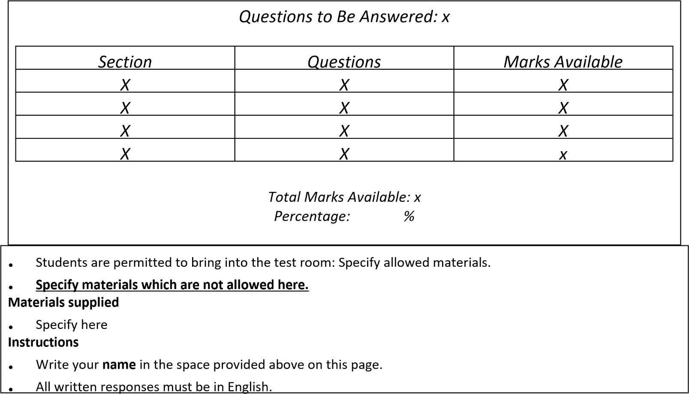

HOMEWORK GUIDELINES
Homework should be:
- Appropriate to the student’s skill level, age and in line with Victorian Curriculum guidelines for that subject.
- Interesting, challenging, and where appropriate, open ended.
- Purposeful, meaningful and relevant to the curriculum.
- Assessed by teachers with written feedback, support and strategies for improvement provided.
- Homework should be corrected, checked and returned in a timely manner.
Late Submission – Years 7 to 10
The following refers to assessment tasks that appear on the subject end of semester report.

Prior to the Task – Teacher Responsibilities
- Deadlines must be made clear, preferably in writing and listed on Compass for parent and student access.
- All assessment criteria must be provided at the commencement of the task.

Student Responsibilities and Protocols
All students must endeavour to meet the deadlines of work submission according to the dates outlined by their classroom teacher. All work should demonstrate an understanding of the subject matter consistent with the student’s ability and be:
- well presented
- thorough
- complete
- submitted on time
If a student is aware that they will not meet the deadline then they should seek an extension of time from their teacher. Students must provide supporting documentation, for example, a medical certificate or note from their parents. If the assessment task is submitted by the negotiated date the work will still be assessed.
A student may apply for an extension of time on the basis of one of the following:
- Illness
- Significant hardship
- Physical disability
- Personal environment
- Death of a family member
- Severe Injury
The classroom teacher may ask the relevant Student Manager for advice regarding these issues or to provide further information before a decision is made.
Applications that will not be accepted include:
- Books at school
- Technology problems
- Overseas holiday
If there is no reasonable explanation for the late submission of work the student will incur a penalty according to the outline listed below.
If a student is absent from school on the day of a deadline because of illness, the task must be submitted on the next school day. If there is no class in the subject in question, it is the student’s responsibility to seek out the teacher. No penalties will apply.
In the case of student absence from the class because of other school business (e.g. excursions, sport, production etc.) work should be submitted on the next school day. If there is no class for the subject in question, it is the student’s responsibility to seek out the teacher. No penalties will apply.
If a student does not meet any of the criteria and expectations listed above then penalties will apply according to the scale listed below.

TIME LATE | PENALTY
1 Week Day | 5%
2 Week Days | 10%
3 Week Days | 15%
4 Week Days | 20%
5 Week Days | 25%
6 Week Days | 30%
7 Week Days | 35%
8 Week Days | 40%
9 Week Days | 45%
10 or more Week Days | 50%
Non-Submission | This equates to 0 on the report.
* Week day includes school days and term holidays.

Late Submission Protocols – Years 7 to 10

Teacher Responsibilities
All teachers are required to contact the student’s parents when an assignment has not been submitted by the due date. Teachers will use the schools preferred method of contact being email and SMS (see Appendix A) through the Compass system to inform the parents of the late submission. This process is to be completed by staff using the ‘Late Submission of Assessment Task’ template in the Compass Chronicle. The SMS and email will automatically be generated by the system and sent to the primary family contact. However, depending on the family circumstances, staff may need to contact home via a phone call or letter (see appendix C). The previous contact methods must be recorded on Compass under ‘Parent Communication’ so a record of the contact is kept by the school.
If the student does not submit the required work the teacher must then complete the ‘Notice of a Low Academic Achievement Result’ template in the Compass Chronicle which will generate an SMS and email (see Appendix B) informing the primary contact of this information. However, depending on the family circumstances, staff may need to contact home via a phone call or letter (see appendix D) to inform parents and communicate this result. Again, the two previous forms of communication this must be recorded on Compass under ‘Parent Communication’. If contact still cannot be made after repeated attempts, the teacher must inform the Student Manager of the student’s circumstances.
If a student submits any piece of work that puts them at risk of receiving a ‘Low Academic’ result for the subject, it is the teacher’s responsibility to again contact the parent using one of the methods listed in the above process. Teachers must also inform the relevant student management team if a student is consistently performing at a low academic level.
Any student who is consistently performing at a low academic level in a number of subjects will be contacted by the relevant Student Manager or Sub-school Leader.
Student Responsibilities
Years 7 to 10 - Students are required to submit all assessment tasks on time according to their teacher’s instructions.

Parent Responsibilities
Parents are required to supply current email and mobile phone number contact details to the school so communication of ‘Late Submission’ and ‘At Risk of receiving a Low Academic result’ messages can be received in a timely manner. This is the schools preferred form of communication and only in exceptional circumstances will alternate forms of communication be used.
Email and SMS communication templates are common templates used by staff, set up in Compass by the College Compass administrator.

VCE LATE SUBMISSION POLICY
This will be enforced according to the Lalor Secondary College VCE Policy document in line with the VCE Administrative Handbook

Appendix A

Non –submission of Assessment Task – Parent Email

NON-SUBMISSION OF ASSESSMENT TASK
{entry created date} Dear {parent name}
{student Name} was required to submit an assessment task for {Subject}. It was not submitted by the due date.
Please be aware that there are penalties for late submission of Assessment Tasks at Lalor Secondary College and these are based on the duration of lateness according to our Learning, Assessment and Reporting Policy (located at the L.S.C website). The penalties may have a significant impact on your child’s ability to achieve satisfactory completion of this subject.
The details of this assessment task can be found on Compass under the relevant subject or by contacting me through the methods suggested below.
If you wish to discuss this matter further, please contact me at the school on 9463 7300 or via
email
Yours sincerely
{staff name}

Non –submission of Assessment Task – Parent SMS

{student name} has not submitted an assessment task by the due date. Please access Compass and contact the relevant classroom teacher for more information.

Appendix B

Low Academic Achievement Result – Parent Email

NOTICE OF A LOW ACADEMIC ACHIEVEMENT RESULT
{entry created date}
Dear {parent name}
This email is to inform you that {student name} has received an Learning Task result of less than 40%. This means they are at risk of not meeting the academic standards set by the college for {Subject}.

For a student to meet the expected level of achievement at Lalor Secondary College and qualify for automatic promotion to the following year level, they must achieve an average of 50% across all the assessment tasks completed in the subject. Currently your child is at risk of not meeting this requirement.

As the school has moved to continuous reporting you can view feedback about the task in question by logging onto Compass. This information is now available and should be accessed to gain a full understanding of why this has occurred.
To assist {student name} in meeting the minimum standard required, a number of strategies have been outlined below that can be implemented. The key strategies listed below will allow for greater academic success in future tasks and beyond. If further assistance is required, please contact me to arrange an appointment on 9463 7300 or email me via my edumail address located on the schools website.
KEY STRATEGIES
- Plan a Homework Timetable, allowing for approximately one hour per night. Provide appropriate study space and supervision.
- Ensure the school diary is being used to record all homework and due dates.
- Encourage your child to ask questions in class and complete as much work as possible in the classroom.
- Encourage your child to see teachers at school outside of class time.
- Encourage your child to attend ASH (After School Homework) every Wednesday in the Lalor Secondary College Resource Centre.
- Ensure regular school attendance.
Regards,
{staff name}

Notice of Low Academic Achievement– Parent SMS

{student name} has received an Assessment Task result in {Subject} of less than 40%. Please access Compass to view feedback for this task for more detailed information.

Appendix C

NON-SUBMISSION OF ASSESSMENT TASK

Date: - ……….

Dear Parent/Guardian,

Your son/daughter __________________________was required to submit an assessment task on ____________.
It was not submitted on this date. The details of this work task are indicated below.

Subject | Assessment task/activity

Please be aware that there are penalties for late submission of Assessment Tasks at Lalor Secondary College and these are based on the duration of lateness according to our Learning, Assessment and Reporting Policy (located at the L.S.C website). The penalties are listed on the back of this letter and may have a significant impact on your child’s ability to achieve satisfactory completion of this subject.
If you wish to discuss this matter further, please contact me at the school on 9463 7300 or via email:
______________________________________@edumail.vic.gov.au
Yours sincerely,

Subject Teacher - ___________________________________

----------------------------------------------------------------------------------------------------------------------------------

Dear Teacher,
I have read and understood that my son/daughter___________________________ will be penalised for the lateness of the above task in accordance with the table overleaf and that this may have a significant impact on my son/daughter’s ability to obtain a satisfactory completion in this subject.

Parent Signature ................................................................................. Date .........................................

If a student does not submit an assessment task by the due date then the following penalties will apply according to the scale listed below.

TIME LATE | PENALTY
2 Week Days | 10%
3 Week Days | 15%
4 Week Days | 20%
5 Week Days | 25%
6 Week Days | 30%
7 Week Days | 35%
8 Week Days | 40%
9 Week Days | 45%
10 or more Week  Days | 50%
Non-Submission | This equates to 0 on the report.
*Week day includes school days and term holidays.

Appendix D

Notice of a Low Academic Achievement LETTER
(date)

Dear Parent/Guardian

This letter is to inform you that {studentName} has received an Assessment Task result of less than 40%. This means they are at risk of not meeting the academic standards set by the college for {Subject}.

For a student to meet the academic standards at Lalor Secondary College, they must achieve an average of 50% across all the assessment tasks completed in the subject. A summary of recently completed assessment task/s is included below.

Assessment Task/s Completed and result :-________________________________________________________________________________

This was due to the following factors highlighted below:
Not handing the task in.

Little effort put into the preparation prior to completing the task.
Had difficulty with recalling the content being delivered under test conditions.
Absences
Other _________________________________________________________________
To assist {studentName} in meeting the minimum standard required, a number of strategies have been outlined below that can be implemented. The key strategies listed below will allow for greater academic success in future tasks and beyond. If further assistance is required, please contact me to arrange an appointment on 9463 7300 or use the parent portal messaging service.

KEY STRATEGIES
- Plan a Homework Timetable, allowing for approximately one hour per night.
- Provide appropriate study space and supervision.
- Ensure the school diary is being used to record all homework and due dates.
- Encourage your child to ask questions in class and complete as much work as possible in the classroom.
- Encourage your child to see teachers at school outside of class time.
- Encourage your child to attend ASH (After School Homework) every Wednesday in the Lalor Secondary College Resource Centre.
- Ensure regular school attendance.
Regards,
(name)
GUIDELINES FOR ADDRESSING PLAGIARISM

DEFINITION
Plagiarism is another word for cheating and involves the act of taking and using the thoughts, writings, inventions or creations of another person and passing it off as one’s own work.
Plagiarism is a breach of copyright laws—hence, committing an act of plagiarism is against the law.
Plagiarism can include:
- Copying— exactly reproducing others’ words, with or without their knowledge.
- Not acknowledging ideas or information taken from another individual or source, for example, in a bibliography or through referencing.
- Knowingly allowing your work to be copied and submitted by someone else.
Plagiarism is regarded as academic dishonesty, theft and an ethical offence
A student who plagiarises or is found to assist another in doing so is acting in a manner that contravenes the school values, particularly Honesty.

AVOIDING PLAGIARISM
- Teachers will make students aware of what behaviours and actions constitute plagiarism and how it can be avoided.
- Teachers will guide students in selecting and using appropriate resources and drafting their work so it can be authenticated.
- With support from library staff, teachers will instruct students about how to reference their research.
- Teachers will develop assessment tasks that are challenging and rigorous and that discourage plagiarism.
- Questions will be worded in a manner that requires students to interpret ideas and analyse them, rather than simply reporting facts.
When investigating acts of Plagiarism it is the responsibility of the student to prove that the work in question is their own. This may be done in discussion with the classroom teacher regarding the process of developing the work or the ideas and concepts contained within the task.
- Students may produce drafts or evidence of research to prove that the work is their own.
- Sources of research and ideas should be acknowledged using bibliographies and appropriate referencing systems. The Library Resource Centre has guides available to advise students about this process.
- Students may be asked to produce work of comparable quality.

CONSEQUENCES OF PLAGIARISM
Work that contains unacknowledged material, is not typical of other work produced by the student, is inconsistent with the teacher’s knowledge of the student’s ability and has not been sighted or monitored by the teacher during its development is cause for concern and will be reported to the relevant Student Managers. Consequences increase as indicated below, depending on the nature of the case of plagiarism.

First Offence: Plagiarism or knowingly providing others with assistance to plagiarise. | - Classroom teacher, Sub School Leader and/or Assistant Principal meet with the student.  - The breach of rules is discussed and student is made aware of the serious nature of the offence.  - The student/s will receive no marks for any work that is found to have been sourced from somewhere else without appropriate acknowledgement, other than in exceptional circumstances (in such a case, the student manager will make the final decision regarding the consequence that is to apply or if an opportunity for redemption may be provided). This includes copying answers from another student during a test and students copying work from other students. If identical work is submitted for assessment by two students, neither student may receive any marks for that work. This decision will be made by the Sub School Leader based on the evidence collected.  - An after school detention is given to the student/s by the Student Manager.  - The case is noted in the Compass by the Student Manager.  - The student completes and resubmits the task
Second Offence: Plagiarism or knowingly providing others with assistance to plagiarise. | - The parent or guardian of the student is contacted to discuss the serious nature of the offence.  - The student will receive no marks for any work that is found to have been sourced from somewhere else without appropriate acknowledgement. If identical work is submitted for assessment by two students, neither student may receive any marks for that work.  - Two after school detentions or a Saturday morning detention are given to the student.  - The case is noted in Compass by the Student Manager.  - The student will be required to attend a library research skills session and be made aware of the legal consequences of plagiarism.  - The student completes and resubmits the task
Repeat Offence of plagiarism or coercion of others to assist in plagiarism. | - A parent meeting is held with the student and Sub School Leader or Assistant Principal.  - The student receives a suspension as appropriate to the situation.  - The incident is recorded in Compass by the Sub School Leader or Assistant Principal.  - The student completes and resubmits the task

Plagiarism by VCE students will be dealt with according to the guidelines in the VCE Student Handbook.

Appendix E

Lalor Secondary College
Compiled by:
    - Laura Forster (FOR): Assistant Principal - Teaching and Learning
    - Ecehan B. Gülbayrak (GUL): Learning Specialist - Literacy

Literacy Improvement Plan 2022
At Lalor Secondary College (LSC) we value academic excellence and celebrate diversity in our curriculum. We do this by supporting open and transparent communication between our school and our community, which is part of our commitment to ensuring the success of every student. This reading plan is to ensure improved literacy outcomes across all KLAs across LSC. This document establishes the reading plan at LSC for 2022.

Rationale
Reading, in particular, the ability to read and comprehend underpins the core tenet of literacy, which is applicable across all subject areas; therefore, at LSC reading is at the fore of our literacy focus to foster these skills to enable our students to be able to participate in their learning.
Each learning area has a reading, writing and speaking curricular component, therefore, to provide a platform of growth, all our teachers are practitioners of literacy, and all have a responsibility in supporting these skills that relate to reading, which in turn, creates an environment where literacy is valued.
NAPLAN 2021 Relative Growth Tabular: Reading
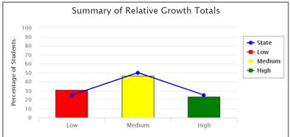
Year 7 - 2021 | Scaled Results & Relative Growth Data for Reading
Year 9 - 2021 | Scaled Results & Relative Growth Data for Reading
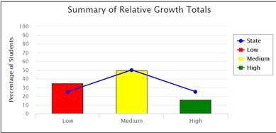

Accountabilities
At LSC, every teacher is a teacher of literacy.
- Every Key Learning Area has a responsibility to teach key vocabulary terms, that are specifically attributed to the Victorian curricular links.
- Every Key Learning Area has a responsibility in reinforcing comprehension strategies that supports differentiated learning needs, including extending advanced learners.
- Classroom discussion and teacher modelling is necessary to build vocabulary and to show students how to utilise the concepts studied in class and express them clearly in written form.
- The Gradual Release of Responsibility lesson structure supports students to progressively take on greater responsibility for their learning by providing opportunities for individual practice to consolidate skills.
- Time for independent reading will be provided within the English curriculum in years 7 to 9 to supplement reading done at home.
- Student learning needs will be identified and acted upon
- Student progress in acquiring skills will be tracked and acted upon to ensure that all students continue to develop skills to their potential.
- Literacy intervention is most effective when direct instruction of strategies is embedded in the regular curriculum and supported in all learning areas.
- While student diversity is best accommodated by differentiating the instruction within the classroom, there are case-specific exceptions where additional interventions will be required, both inside and outside the program to address identified learning needs.
- Effective instruction requires systematic monitoring and use of assessment data.
- Formative assessment is the foundation for supporting literacy learning through matching teaching strategies to individual student needs during curriculum planning.
- Effective instruction requires systematic monitoring of student learning and use of this data to adjust learning and track progress.

Implementation
Literacy is a whole school priority and will be supported by providing adequate professional development and given status within each KLA.
1. Students will make the greatest progress where teaching is consistently delivered across classrooms and all subject areas plan to address the specific literacy demands of their content area.
2. Allocation of curriculum time for skill development is a key element in allowing students to build and consolidate skills. Each KLA must have a Literacy Action Plan that is in-line with their syllabus. The Literacy Action Plan must incorporate actionable and assessable literacy goals.
3. English classes will be allocated a minimum of 3 periods per week at Years 7 to 9. Of this time, a minimum of 15 minutes must be dedicated to independent reading time. Students in year 7 will be provided with a reader. This reader will include a novel and reading pocket. Students in year 7 must bring their reader to every English class and are encouraged to use their reader during scheduled Library sessions, to borrow and keep track of their reading. Students in year 8 and 9 must also bring a novel to read during the independent reading period. The novel cannot be the text that is being analysed as part of a unit of work, nor can it be a textbook from another subject area. The novel must a book outside of the year level curriculum. Teachers are encouraged to book in library sessions to bring the implementation of the reading culture at LSC.
4. English teachers must allocate, at least, the equivalent of one period per fortnight to an independent reading program where students are actively guided in their reading development by the class English teacher. This will include regularly monitoring student progress through conferences and diagnostic assessment according to the LSC assessment schedule.
5. A Diagnostic Assessment Schedule will be developed to ensure that student literacy learning needs are identified and that progress is tracked to allow targeted teaching to address student learning needs. A range of general and individual learning plans will be developed to ensure that each student’s literacy needs are being explicitly addressed.
6. Systematic professional learning will be delivered both at a whole school level and to teams and individuals through coaching sessions. Priorities for professional learning will be identified through LSC’s Annual Implementation Plan (AIP) and further refined in the College Literacy Plan in order to have a focused approach The goal of all professional learning is to see changed practices evident in classrooms consistently across LSC.
7. Opportunities need to occur for professional dialogue about the learning needs of specific students and strategies which can help to address these needs. This will occur through CAT meetings based on information collected through the diagnostic assessment schedule as well as through other Professional Learning Communities (PLC) formed for this purpose.

Developing a Reading Culture
Students must be awarded opportunities to be able to practice independent reading. To support the establishment of a culture for reading, at the beginning of each English lesson, all teachers who teach year 7, year 8 and year 9 English, must dedicate at least 15 minutes of reading time at the beginning of each lesson, for this to occur.
Wider reading around each subject area will reinforce these comprehension strategies. The LSC Library and Lexile Library will play a core role in promoting a reading culture across the College.

Roles and responsibilities
The Literacy Leader
- Managing the Literacy Program across LSC.
- Managing the collection, use and distribution of literacy data and developing protocols for the use of this data.
- Coordinating the analysis of literacy diagnostic assessment for the whole school, year, class, and individual levels
- Supporting the provision of the BOOST program.
- Establishing and resourcing classrooms to support literacy.
- Conducting literacy coaching.
- Organising Professional Learning sessions for all staff to develop consistent literacy practices across all KLAs.
- Responsible for supporting teachers to change their practice and implement effective literacy procedures by working with teachers.
- Support teachers to work more effectively to address the learning needs of their students.
- Review the literacy demands in curriculum units.
- Conduct discussions with teachers to identify areas to work.
- Model lessons and observe teachers practicing literacy strategies.
- Responsible for identifying the literacy demands of KLAs and help class teachers to plan to address this through the curriculum.

The BOOST Leader
- Developing a support program for students with additional literacy needs.
- Coordinating the analysis of literacy diagnostic assessment for individual students.
- Supervising the provision of the BOOST program.
- Establishing and resourcing BOOST classrooms to support literacy.
- Supporting the supervision of literacy coaching.
- Organising Professional Learning sessions for all staff to develop literacy practices.
- Support teachers to work more effectively to address the learning needs of their students, including individual students.
- Conduct discussions with teachers to identify areas for literacy intervention.
- Model lessons and provide opportunities to debrief to reflect on learning.
- Develop Individual Learning Plans (ILP).
- Support BOOST teachers in developing Individual Learning Plans (ILP).

English Teachers
In addition to the responsibilities of the classroom teacher, English teachers also have additional responsibilities in ensuring the literacy capabilities of LSC students across all learning domains. These include:
- Responsible for implementing effective literacy practices in their teaching.
- Review the literacy demands of the curriculum and address the literacy demands in their syllabi and teaching timelines.
- Implement 15 minutes of reading at the beginning of each English lesson.
- Conduct, use and apply Lexile testing at the beginning, middle and end of the academic school year.
- Assess reading skills, including incorporating an explicit reading element in at least one CAT per semester.
- CATS will be provided with an analysis of the learning needs of the cohort based on earlier NAPLAN testing and current diagnostic assessments in the form of skills that need to be addressed.
- English year level leaders will lead discussions about the teaching approaches that will facilitate reading skills and assessing literacy.
- Address the learning needs of their students, including the reading abilities of their students and extend their students’ reading abilities.
- Coordinate and use diagnostic data to inform teaching units, including PAT, NAPLAN and Lexile data.
- Collect and use literacy data as a measure to review practices in the English faculty.
- Embed effective literacy practices in every English lesson.

Classroom teachers
- Responsible for identifying the literacy demands of their subject areas and plan to address this through the curriculum.
- Incorporate explicit reading tasks regularly in lesson plans.
- Teachers model and explicitly explain the tasks and the literacy components alongside the content they are teaching.
- Student learning is differentiated to achieve success and are provided with feedback to improve all their skills including literacy.
- Students are given frequent opportunities to practise and develop their literacy knowledge and skills.
- Formative assessment of both a formal and informal nature is used across all content areas to give students feedback on their growth in literacy skills as well as content knowledge.
- Identify and teach subject-specific terminology that is relevant to the content.

Data Manager
- Coordinate appropriate and timely testing to inform teaching practice to literacy.
- Integrate ongoing development of relevant data, processes and procedures into LSC’s existing information management infrastructure.
- Act as key liaison between staff and data literacy.
- Make recommendations to inform decision-making and improve student performance, specifically focusing on student literacy abilities.
- Create, manage and support the data input and record keeping of staff and student data.
- Present an analysis of the data to relevant teams.
- Facilitate professional learning activities to improve staff data literacy, in particular the interpretation and use of student achievement data to improve student learning.
- Work with the KLA Leaders in the development and implementation of strategies for the use of student performance data to improve teaching.
- Make recommendations to inform decision-making and improve student performance, specifically focusing on student literacy abilities.
- Create, manage and support the data input and record keeping of staff and student data.

Library staff
- Maintaining a vibrant reading area.
- Supporting student learning.
- Promoting reading across the school.
- Supporting the teaching of research skills.
- Ensuring the continuation of the Library Orientation Program.
- Implement the Premier’s Reading Challenge.

Parents & Guardians
Partnerships that link the home, the school and the community are important to improving literacy. Parents can support the literacy development of their children by:
- Taking an interest in their reading and discussing their current reading.
- Parents can enhance this partnership by maintaining liaison with the school and teachers to be aware of the progress being made.
- Raise concerns about the learning rate of their child.
- Support and incorporate literacy improvement strategies from teachers.
- Follow and act upon suggestions contained in the LSC newsletter in relation to literacy improvement.

Students
Students learn most effectively when they play an active role in their own learning. Students should set goals to improve their skills based on feedback from diagnostic testing and class results. Regular reading significantly improves student performance across all their learning. Students will be provided opportunities to read widely at school and are expected to read for at least 30 minutes per night in line with the College Homework Policy.

Testing & Data Evaluations
All students in Years 7 to 10 will be tested during the year using a variety of formal diagnostic literacy tools, including Lexile, Fountas & Pinnell, PAT and On Demand testing. These results will be triangulated with the NAPLAN data with observed data from teacher reading conferences by the English teachers.
Data will be made available electronically for easy access. Teachers will have an opportunity in curriculum meetings and PLCs to consider the students in their classes and plan for addressing their needs.
This data will be analysed by the Literacy Leader and BOOST Leader to identify students with significant learning needs. According to the results, student needs will be addressed through either a Year Level, Group or Individual Learning Plan.
Year level plans – All CATS will be provided with an analysis of the learning needs of the cohort based on earlier NAPLAN testing and current diagnostic assessments in the form of skills that need to be addressed. This will be used to identify general skills that should be addressed through the curriculum. Improvement will be tracked at a whole school level.
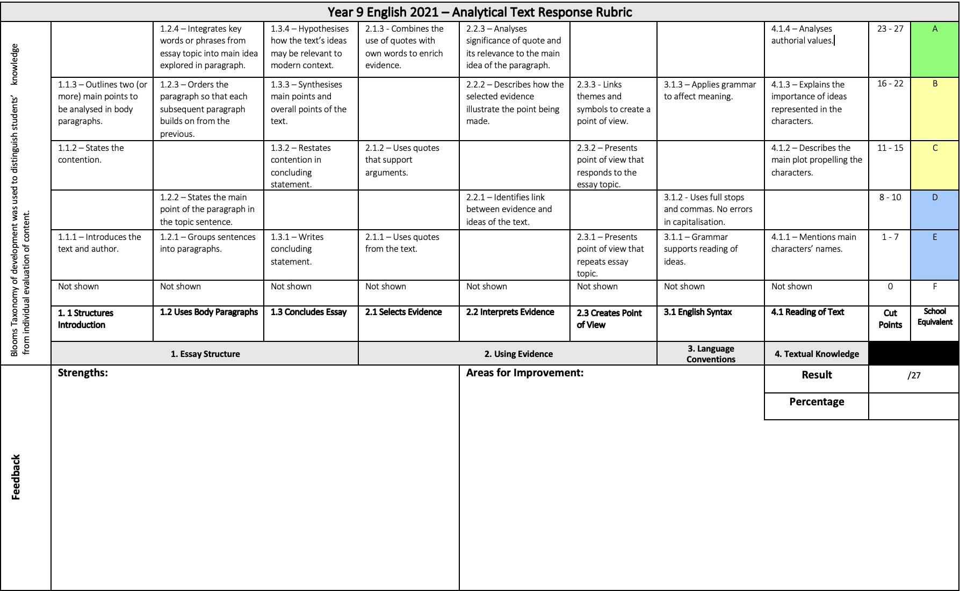
Year 9 - Victorian Curricular Links: Reading and Responding | Rubric Exemplar
The phases within a learning continuum can be used to identify learning intentions and classroom activities for students. This helps teachers target their teaching. During these phases, it is important to recognise that learning is complex and that the teacher has responsibility to create a rubric that reflects that complexity, by working on the phases they are ready to learn and also spend time consolidating phases they have recently achieved via a rubric.
Group plans – A list of students who are between 1 and 2 years behind or more than one year ahead in their literacy development will be compiled at the start of each year that details the specific areas of comprehension that these students struggle with or at which they excel. This will be distributed to class teachers to ensure that their planning uses a range of approaches and texts of suitable levels that will accommodate the learning needs of these students.
Individual plans – Students who are greater than 2 years behind or above the expected achievement in literacy will have an individual learning plan developed. Individual teachers will be supported to develop and implement strategies that scaffold the learning of these students.
As part of an ongoing evaluation process the Literacy Specialist will review the effectiveness of the Literacy Policy at the conclusion of each year. Improvements to the processes and procedures will be adapted when required.
This policy will be reviewed in line with the LSC Annual Implementation Plan (AIP).

